UNIVERSITY OF BUEA

Faculty of Science

Department of Computer Science

SmartFarm

Design and Implementation of a Smart Farm Management System for West Farms

Submited by Group 1

- Gitfaknwi Gideon Nemfor SC23A443
- Andoseh Rinnah SC23A534
- Tayu Prosper Nyuidzi SC23A725
- Mbi Stacy Ndang SC23A644
- Zemenjouh Faith Yimnai SC23B991
- Chief Bakia Nforsong SC23A561

Supervised by: Dr Ali Joan Beri Wacka

Academic Year: 2025/2026

Communication

1.1 Introduction
Agriculture is a cornerstone of Cameroon's economy, providing food security and livelihoods for millions of families, particularly in the North West, South West, West, and Adamawa regions. Farmers in these areas cultivate crops such as cocoa, coffee, plantain, maize, and cassava, while raising livestock including cattle, goats, pigs, and chickens.
Despite this importance, farm management in Cameroon remains largely informal. Records are maintained in notebooks, financial decisions are based on memory, and there is no centralized system for tracking activities, supplies, or workers. This fragmentation leads to inefficiency, waste, and missed opportunities for growth.
SmartFarm is a web-based farm management system developed to address these challenges. It integrates all farm management tasks into a single, mobile-friendly platform built with Next.js, TailwindCSS, and Supabase, enabling farmers to manage their operations more efficiently and make data-driven decisions.

1.2 Problem Statement
Cameroonian farmers lack a centralized, easy-to-use digital system for managing their farm operations. As a result, critical farm information — including crop and livestock records, supply inventories, financial transactions, and worker task assignments — is scattered across notebooks, phone calculators, and memory. This fragmentation causes records to be lost or forgotten, makes it impossible to track farm performance in real time, and prevents farmers from making informed decisions about budgeting, supply ordering, or seasonal planning.
The absence of an integrated management tool means that farmers cannot easily detect problems such as supply shortages, crop disease, or cash flow deficits early enough to respond effectively. Workers also lack clear direction, as tasks are communicated verbally without any system for tracking completion or accountability.
SmartFarm is proposed as a solution to this problem: a unified web platform where Cameroonian farmers can record daily activities, manage crops and livestock, track supplies and finances, and assign tasks to workers — all from a phone or computer, in a simple interface designed for users with limited digital experience.

1.3 Project Aim and Objectives

1.3.1 Aim
To design and build a smart, easy-to-use farm management system that helps Cameroonian farmers run their farms more efficiently by centralizing all farm information in one accessible platform.

1.3.2 Objectives
- To build a web platform where farmers can store and access all farm information in one place
- To enable real-time recording and tracking of crop growth stages and livestock health
- To provide an inventory management system for supplies such as seeds, fertilizer, feed, and medicine
- To allow farmers to record income and expenses and generate simple financial reports
- To allow managers to assign tasks to workers and monitor completion
- To display charts and dashboards that help farmers understand their farm's performance

Requirement Gathering

2.1 Purpose of Gathering
The goal of this activity was to identify the real needs of Cameroonian farmers and agricultural stakeholders before any development began. Rather than building a system based on assumptions, we conducted interviews to ensure that SmartFarm addresses genuine problems.

2.3 Technique Used
The primary data collection technique used was face-to-face interviews conducted at the FAVM (Faculty of Agriculture and Veterinary Medicine) farm on 24th April 2026. Both open-ended and structured interview styles were employed. Open-ended questions allowed participants to describe their problems freely, while structured questions ensured consistent coverage of key topics across all interviews.

2.3.1 Sample Interview Questions
- How do you currently keep records of your farm activities?
- How do you know when your supplies are running low?
- How do you track how much money your farm makes each season?
- What is the biggest problem you face managing your farm?
- Would you use a website or phone app to manage your farm?

2.3.2 Key Findings from Interviews
Atsafack Nidele (Agronomy Student): "One of the biggest challenges I face is detecting crop diseases very late, and lacking the knowledge to identify the disease and its treatment. I also face difficulty in marketing harvested products, which I normally do using word of mouth — limiting my market audience to people I already know."
Caleb (Farmer, 20 years): "The most pressing challenges I have faced are difficulty accessing government loans, limited availability of animal feed, and the inability to effectively compare yields over time. I am ready to adopt a smart farm system — it could streamline my work and reduce labour costs."
Gabriel Nemfor and Jenny Agbor (Animal Science Students): "We face major difficulties accessing equipment, a lack of skilled operators for modern tools, and manual record keeping is often confusing. Illiteracy among older farmers may hinder adoption — but we believe younger farmers will rapidly embrace such a system."

2.4 Functional Requirements
These are the specific actions the system must be able to perform:
- The system must allow users to create an account and log in securely
- The system must allow farmers to add, edit, and delete crop records
- The system must allow farmers to add, edit, and delete livestock records
- The system must record daily farm activities with date, description, and responsible person
- The system must automatically reduce supply quantities when they are recorded as used
- The system must send alerts when a supply item drops below a defined threshold
- The system must record income and expense transactions
- The system must generate simple profit and loss reports
- The system must allow managers to create tasks and assign them to specific workers
- The system must display a dashboard with key farm metrics at a glance

2.5 Non-Functional Requirements
These are the quality properties the system must possess:
- Security: Only the farm owner and authorized workers may access the farm's data; passwords must be encrypted
- Performance: The website must load quickly even on slow internet connections, with offline mode support
- Usability: The interface must be simple enough for a farmer with limited computer experience
- Portability: The system must function on both mobile phones and desktop computers
- Reliability: No data must be lost; all records must be saved and recoverable
- Maintainability: The codebase must be clean and modular for easy future updates

2.6 User Interface Requirements
- The design must be clean and uncluttered for easy reading on small phone screens
- Buttons and menus must be large enough to tap with a finger on a touchscreen
- The system should support both English and French (Cameroon's two official languages)
- Error messages must be written in simple, clear language
- The system must display feedback after every action (e.g., 'Record saved successfully')

Feasibility Study

3.1 Technical Feasibility
The tools selected for SmartFarm are all widely used, well-documented, and free to access. Next.js is a mature React framework used by companies of all sizes to build fast, scalable web applications. Supabase provides a fully managed PostgreSQL database with built-in authentication, real-time subscriptions, and a RESTful API — removing the need to build a custom backend from scratch. TailwindCSS enables rapid, consistent UI development.
The development team consists of students at the University of Buea who have been trained in web development and database systems as part of their academic programme. The skills required to implement SmartFarm — including frontend development, database design, and API integration — are well within the team's capabilities.

3.2 Economic Feasibility
The financial cost of building SmartFarm is minimal because all core tools are open-source and free. The primary investment is the development time contributed by the project team. For end users, the only requirements are a smartphone and basic internet access — both of which are increasingly common among younger farmers in Cameroon.
In the future, SmartFarm could be offered as a low-cost subscription service to recover development and hosting costs, while remaining affordable for small-scale Cameroonian farmers.

3.3 Operational Feasibility
SmartFarm is designed to require minimal technical skill. Farmers do not need programming knowledge or advanced computer literacy. The interface uses simple language, recognizable icons, and step-by-step forms. Help pages and training materials will be included within the system itself.
The use of Supabase for hosting means the system is accessible from anywhere with an internet connection, and future offline support is planned to serve farmers in rural areas with limited connectivity. Feedback from the field interviews confirmed that younger farmers and students are enthusiastic about adopting such a system.

3.4 Decision Table: User Login and Data Access
The following decision table shows how SmartFarm handles all possible login scenarios:
Condition / Action | Rule 1 | Rule 2 | Rule 3 | Rule 4
Internet is Available | No | No | Yes | Yes
User is Logged In | No | Yes | No | Yes
ACTIONS
Show Offline Error Page | ✔ | ✔
Show Login Page |  | ✔ | ✔
Allow Access to Dashboard |  |  |  | ✔
Sync Data to Server |  |  |  | ✔

System Analysis

4.1 System Overview
SmartFarm is a multi-module web application. Each module targets a specific area of farm management. At its core, the system is built around three principles: centralization of all farm data in one place, automatic updates when records are entered (e.g., supply deduction), and the transformation of raw data into useful reports and visualizations.

4.1.1 Algorithm: Farm Management Process
- Start
- Display Login Page
- User enters username and password
- Validate user credentials
- If credentials are invalid:
  - Display error message
  - Return to Login Page
- Else:
  - Grant access to Dashboard
- Display available modules:
  - Crop Management
  - Livestock Management
  - Worker Management
  - Inventory Management
  - Expense Management
  - Reports
- User selects a module
- User enters, updates, or deletes farm records
- Validate input data
- Save data to database
- Update dashboard statistics
- Generate reports if requested
- Display updated information
- User logs out
- End

4.1.2 System Flowchart
The flowchart provides a graphical representation of the operational processes of the SmartFarm system. It illustrates the sequence of activities performed by the system, beginning with user authentication and proceeding through farm management functions such as crop management, livestock management, inventory tracking, expense recording, and report generation. The flowchart helps to visualize the flow of information and decision-making processes within the system, thereby improving understanding of how the various components interact to achieve efficient farm management.
Figure 4.1.2: SmartFarm System Flowchart

┌───────────┐
│ START │
└─────┬─────┘
│
▼
┌────────────────┐
│ User Login │
└──────┬─────────┘
│
▼
┌──────────────────┐
│ Validate Login? │
└───┬─────────┬────┘
│Yes │No
▼ ▼
┌────────────────┐ ┌────────────────┐
│ Open Dashboard │ │ Display Error │
└──────┬─────────┘ └──────┬─────────┘
│ │
└─────────┬─────────┘
▼
┌────────────────────────┐
│ Select Management Area │
└──────────┬─────────────┘
│
▼
┌──────────────────────────────┐
│ Add / Update / Delete Record │
└──────────┬───────────────────┘
│
▼
┌─────────────────────┐
│ Save to Database │
└─────────┬───────────┘
│
▼
┌─────────────────────┐
│ Generate Reports? │
└───────┬───────┬─────┘
│Yes │No
▼ ▼
┌──────────────┐ │
│ Show Reports │ │
└──────┬───────┘ │
└────┬─────┘
▼
┌────────────────┐
│ User Logout │
└──────┬─────────┘
▼
┌─────────┐
│ END │
└─────────┘

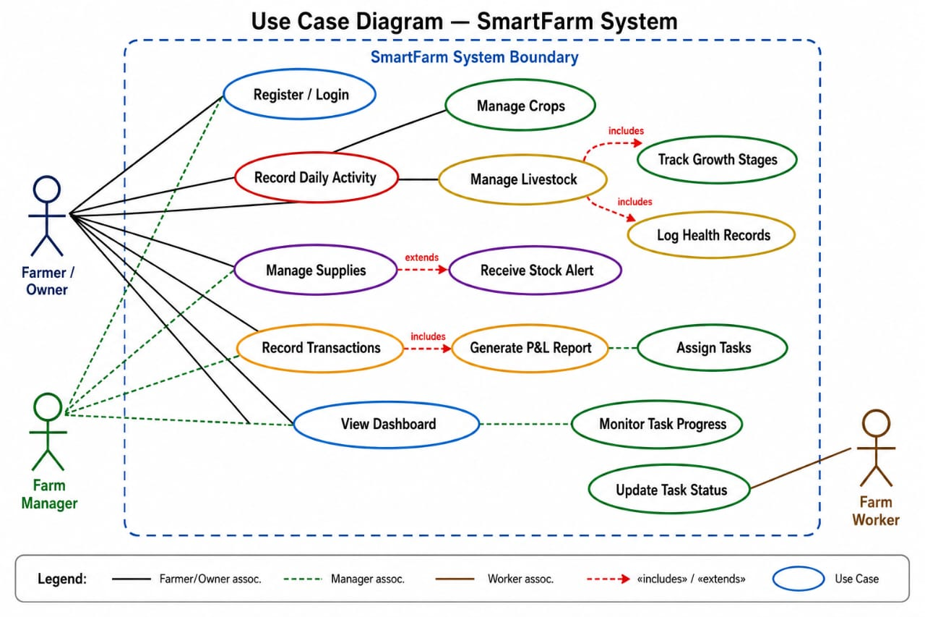

4.2 Data Flow Diagrams (DFD)

4.2.1 Level 0 DFD — Context Diagram
The Level 0 DFD presents SmartFarm as a single system, showing who interacts with it and what information flows in and out.
External Entities:
- Farmer — the primary user who enters data and reads reports
- Farm Worker — receives tasks and marks them as completed
- Farm Manager — assigns workers, monitors progress, and reviews reports
Data flows into the system: farm activities, animal records, crop records, supply usage, income/expenses, and task updates.
Data flows out of the system: activity reports, financial summaries, low-stock alerts, harvest forecasts, and task status updates.
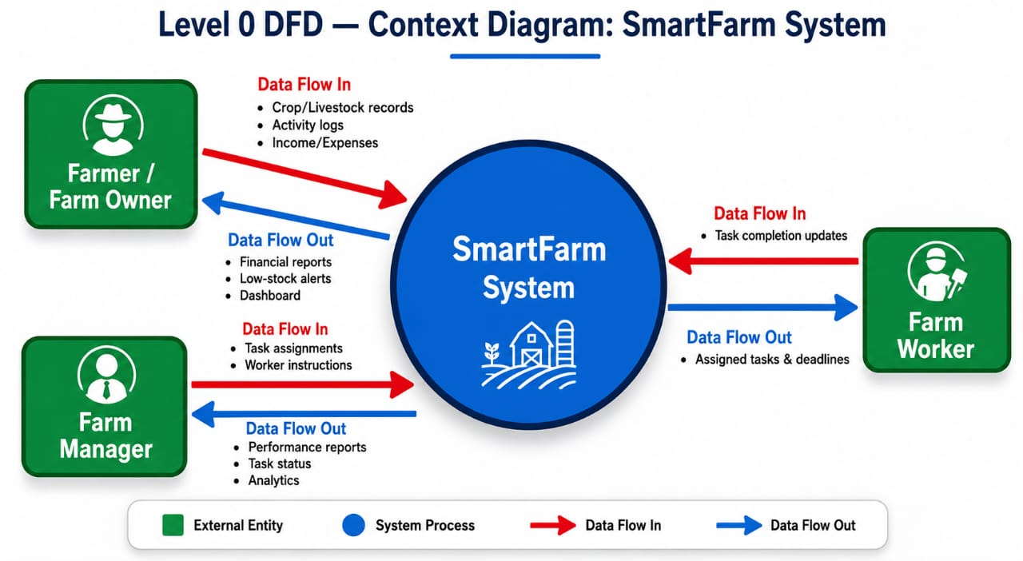
[Farmer / Farm Manager / Farm Worker] → (SmartFarm System) → [Reports / Alerts / Dashboard]

4.2.2 Level 1 DFD — System Modules
The Level 1 DFD breaks SmartFarm into its main processing modules and shows data flows between them.
From (Entity / Store) | Process | To (Entity / Store)
Farmer | Login credentials → Process 1 (Login) | DS1 – User Store
DS1 – User Store | Verified user → Dashboard access | Farmer / Manager
Farmer | Activity details → Process 2 (Record Activity) | DS2 – Activity Store
Farmer | Crop/animal info → Process 3 (Farm Records) | DS3 – Farm Records Store
Farmer | Supply usage → Process 4 (Inventory) | DS4 – Inventory Store
DS4 – Inventory Store | Low-stock alert → Process 4 | Farmer (Alert)
Farmer | Income/expense → Process 5 (Financials) | DS5 – Financial Store
Manager | New task → Process 6 (Task Management) | DS6 – Task Store
Farm Worker | Task update → Process 6 | DS6 – Task Store
DS2 – DS6 | All data → Process 7 (Reports) | Farmer / Manager (Dashboard)

4.3 Data Stores
- DS1 – User Store: login credentials and account information for all users
- DS2 – Activity Store: all recorded daily farm activities
- DS3 – Farm Records Store: all crop and livestock records
- DS4 – Inventory Store: supply types, quantities, and low-stock thresholds
- DS5 – Financial Store: all income and expense records
- DS6 – Task Store: tasks, assignees, deadlines, and completion status

4.4 System Workflow
The operational loop of SmartFarm follows these steps:
- The farmer logs in to SmartFarm from their phone or computer
- They record what happened on the farm that day (e.g., fed 50 chickens, applied fertilizer)
- The system saves this information to the appropriate data store in Supabase
- If supplies were used, the inventory is reduced automatically
- If money was spent, the financial record is updated
- The system processes all data and prepares reports and charts
- The farmer opens the dashboard at any time to view the latest farm status
This creates a simple, self-sustaining loop: the farmer inputs data, the system processes and stores it, and the farmer receives meaningful insights and alerts in return.

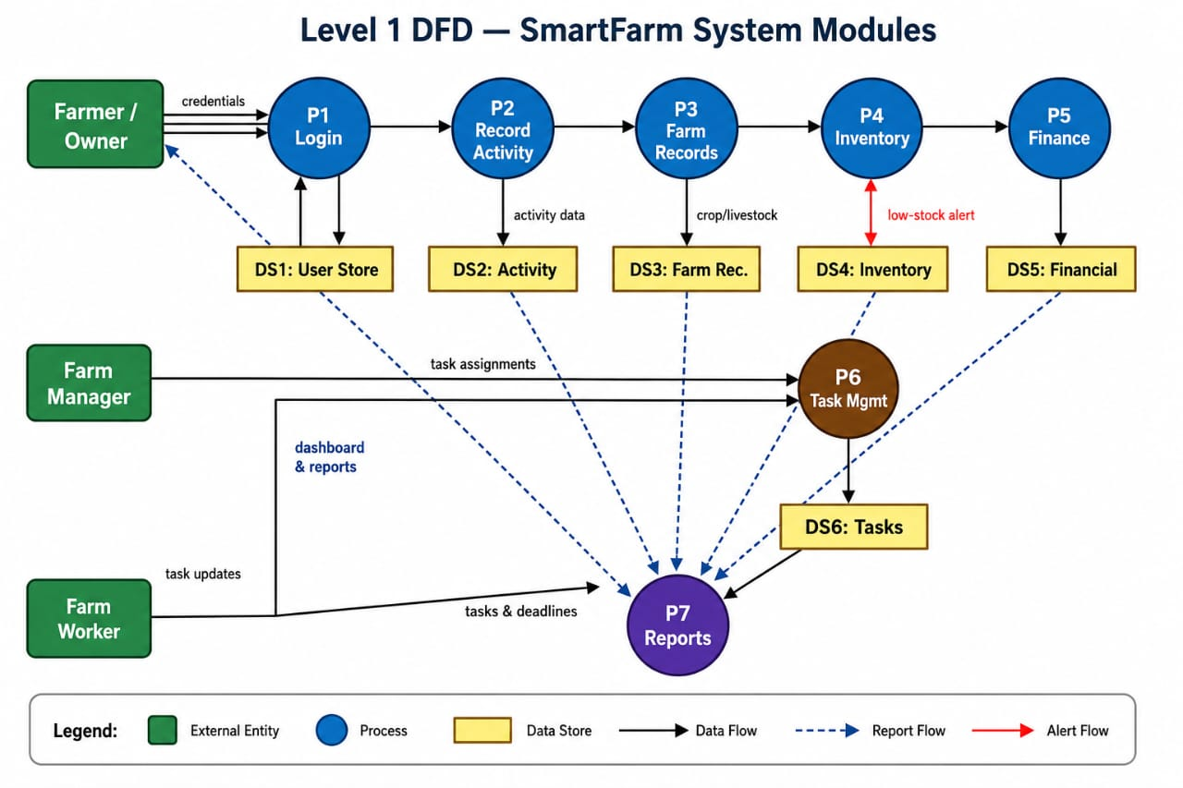

Software Design

5.1 Technology Stack
Layer | Technology | Purpose
Frontend | Next.js | Web application framework for fast, server-rendered pages
Styling | TailwindCSS | Utility-first CSS for responsive, mobile-friendly design
Backend / Database | Supabase (PostgreSQL) | Data storage, user authentication, and API layer
Real-Time | Supabase Subscriptions | Push updates to the UI without page refresh

5.2 System Architecture
SmartFarm follows a client-server architecture:
- Client Side: The farmer's phone or browser runs the Next.js web application
- API Layer: All data interactions go through Supabase's RESTful and real-time APIs
- Database Layer: PostgreSQL (managed by Supabase) stores all farm records persistently
- Real-Time Layer: Supabase subscriptions push changes to connected clients immediately

5.3 System Modules

5.3.1 Login and Account Management
Handles user registration and sign-in using Supabase Auth. Supports role-based access so that farm owners, managers, and workers see only what is relevant to them.

5.3.2 Farm Activity Recording
Farmers record daily activities (planting, feeding, harvesting, treatment) with a date, description, and the name of the person responsible. All entries are stored in the Activity Store and viewable in a searchable history log.

5.3.3 Crop Management
Farmers register each crop with its type, planting date, and field location. The system tracks growth stages, soil treatment schedules, watering records, expected harvest dates, and actual harvest quantities.

5.3.4 Livestock Management
Each group of animals is registered with a name/ID, species, and date of birth. Farmers log vaccinations, health treatments, feeding schedules, and breeding records. A full health history is maintained for each animal group.

5.3.5 Inventory and Supply Management
All supplies (fertilizer, seeds, feed, medicine) are tracked in real time. When a supply is recorded as used, the quantity is automatically deducted. The system triggers an alert when any item falls below its defined minimum threshold. Equipment and maintenance history are also stored.

5.3.6 Financial Management
Farmers record income from product sales and expenses from supply purchases, labour, and transport. Each transaction can be linked to a specific farm activity. The system generates profit and loss summaries and monthly financial reports.

5.3.7 Task and Worker Management
Farm managers create tasks, set deadlines, and assign them to specific workers. Workers can mark tasks as done from their own view. Managers see a real-time overview of pending, in-progress, and completed tasks.

5.3.8 Reports and Dashboard
The main dashboard displays key metrics at a glance: total active crops, total animals, recent expenses, and tasks due today. Charts show production trends, monthly income vs. expenses, and supply usage over time. All data is pulled live from Supabase.
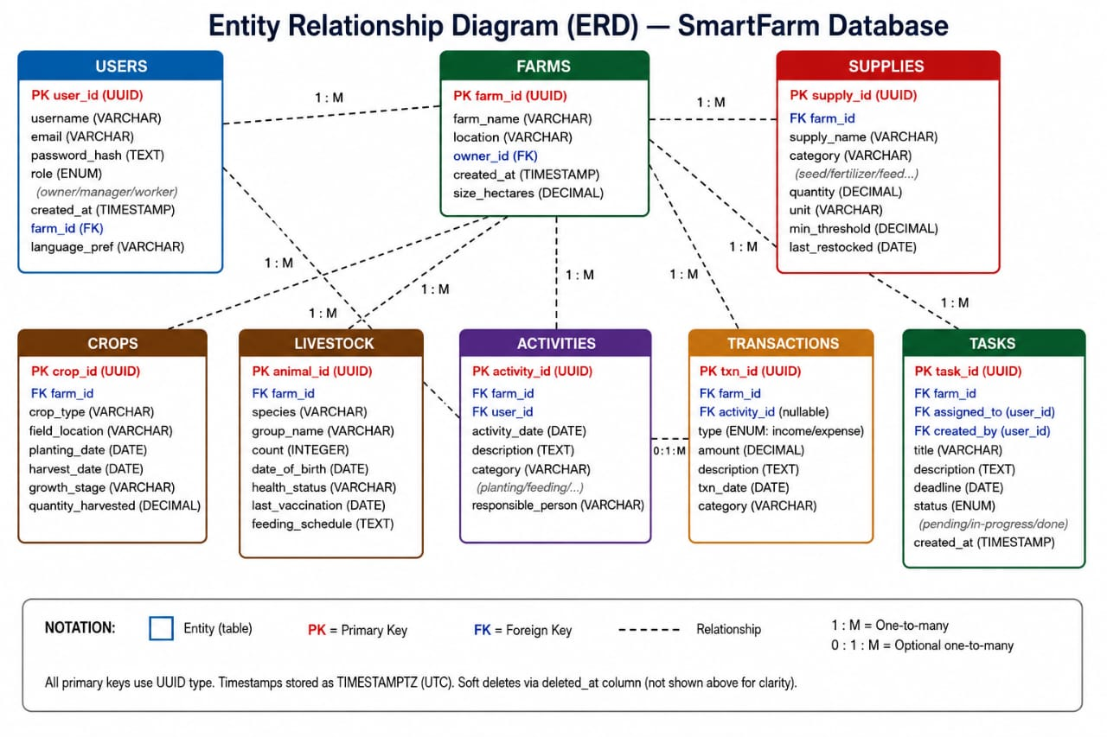
5.4 Gantt Chart
A Gantt chart was developed to illustrate the schedule and timeline of activities involved in the development of the SmartFarm system. The chart provides a visual representation of the project's tasks, their durations, and the sequence in which they were carried out. The development process began with requirements gathering and system analysis, followed by database design, user interface design, frontend and backend development, system integration, testing, documentation, and deployment. The Gantt chart helped in monitoring project progress and ensuring that development activities were completed within the planned timeframe.

Figure 5.4: SmartFarm Project Gantt Chart

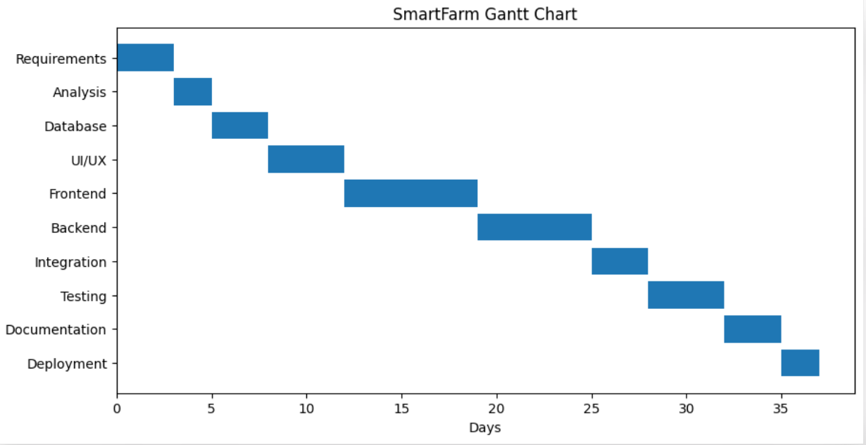

5.5 PERT Chart
The Program Evaluation and Review Technique (PERT) chart was used to represent the sequence and dependencies of activities involved in the development of the SmartFarm system. The chart illustrates how each project task relates to others and identifies the order in which activities must be completed to achieve successful project implementation. By mapping task dependencies, the PERT chart provided a clear overview of the project's workflow and assisted in planning, coordination, and project management throughout the development lifecycle.
Figure 5.5: SmartFarm Project PERT Chart

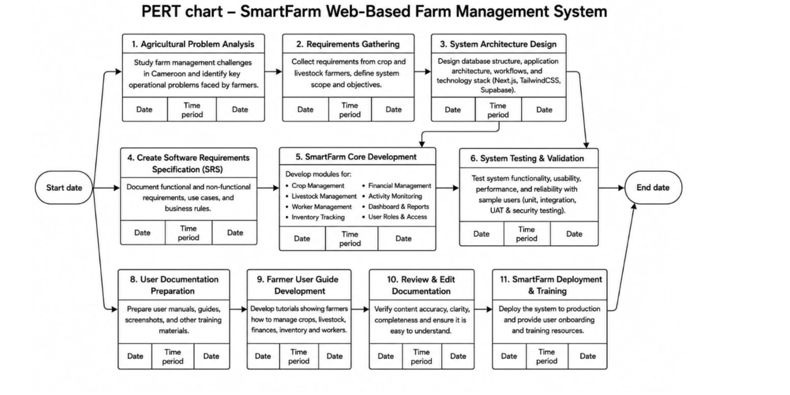

5.6 Quality Assurance and Testing
Quality assurance and testing were conducted throughout the development of the SmartFarm system to ensure that the application functions correctly, meets user requirements, and provides a reliable user experience. The testing process focused on verifying the functionality, usability, performance, and security of the system.

5.6.1 Quality Assurance Approach
The quality assurance process involved continuous verification of system requirements during development. Each module was tested individually before being integrated into the complete application. Regular code reviews and debugging sessions were carried out to identify and resolve errors early in the development process. The use of modern development frameworks such as Next.js and Supabase also contributed to system reliability through built-in security and validation features.

5.6.2 Functional Testing
Functional testing was performed to ensure that all system features operate according to the specified requirements. The following functionalities were tested:
- User registration and login.
- Dashboard display and navigation.
- Crop management operations.
- Livestock management operations.
- Worker management functions.
- Inventory tracking and updates.
- Expense and financial record management.
- Report generation and data retrieval.
The results confirmed that all modules performed their intended functions correctly.

5.6.3 Integration Testing
Integration testing was conducted to verify that different system components communicate effectively with one another. Data entered in one module was checked to ensure that it was correctly reflected in related sections of the application. For example, inventory updates were verified after livestock and crop activities were recorded.

5.6.4 Usability Testing
Usability testing was carried out to evaluate the ease of use of the system. The interface was assessed for simplicity, accessibility, and responsiveness across different screen sizes. Feedback from test users indicated that the system was easy to navigate and that information could be accessed quickly.

5.6.5 Performance Testing
Performance testing was conducted to determine how efficiently the application responds to user requests. Key pages and database operations were monitored to ensure acceptable loading times. The results showed that the system maintained stable performance during normal usage conditions.

5.6.6 Security Testing
Security measures were tested to protect user data and prevent unauthorized access. Authentication and authorization mechanisms provided by Supabase were verified to ensure that only registered users could access protected resources. Input validation was also implemented to reduce the risk of invalid or malicious data being submitted to the system.

5.6.7 Test Results Summary

Test Case | Expected Result | Actual Result | Status
User Login | User successfully logs in | Successful login achieved | Passed
Add Crop Record | Crop information saved | Record stored correctly | Passed
Add Livestock Record | Livestock information saved | Record stored correctly | Passed
Update Inventory | Inventory data updated | Update successful | Passed
Record Expenses | Expense details saved | Expense recorded successfully | Passed
Generate Reports | Reports generated accurately | Reports displayed correctly | Passed
User Logout | User session terminated | Logout successful | Passed
The testing process demonstrated that the SmartFarm system satisfies its functional requirements and provides a stable, secure, and user-friendly environment for managing farm operations.

5.7 SDLC Model: Iterative Development
The team will use the Iterative Model to build SmartFarm. This approach is well-suited to a multi-module system because it allows features to be built and tested in stages, with user feedback informing each successive iteration.
Iteration | Focus | Features
1 | Core Foundation | User login/registration, main dashboard, farm activity recording
2 | Farm Records | Crop management, livestock management
3 | Resources | Inventory management, financial management
4 | Operations | Task and worker management, reports module
5 | Release | Full system testing, bug fixing, and deployment preparation
After each iteration, the team will present new features to farmers or agriculture officers and collect feedback to guide the next round of development.

Expected Benefits
- All farm information in one place, eliminating scattered notebooks and spreadsheets
- Reduced time spent on manual calculations and paperwork
- Clear visibility into farm finances — income, expenses, and profitability
- Better supply management, reducing waste from over- or under-ordering
- Workers know their tasks and deadlines; managers can track completion
- Data-driven decisions based on real farm records, not guesswork
- Scalable for both small family farms and larger commercial operations

Future Enhancements
- A mobile app with offline mode for farmers in areas with no internet access
- Full French language support to serve Francophone farmers across Cameroon
- Automatic harvest predictions based on historical data and weather inputs
- SMS integration so farmers without smartphones can receive alerts by text message
- IoT sensor integration for monitoring soil moisture and temperature in the field
- A market price tool showing current local prices for farm products

SmartFarm — Helping Cameroonian Farmers Grow More, Waste Less, and Earn More.

